Graph: The Wealth Gap Between Blacks and Whites Has Tripled Since 1984. Here’s Why.
POST BY: BENJAMIN LANDY , ON MARCH 1, 2013
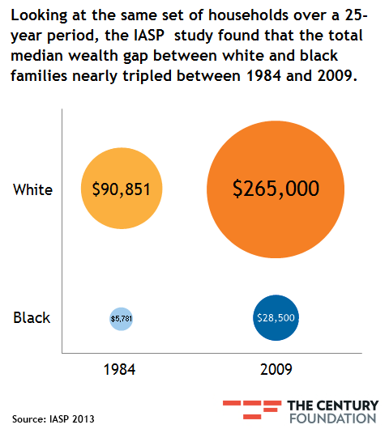
Comparing million-dollar bonuses for bankers to stagnant middle-class wages is a popular way to measure income inequality in the United States. But this narrow focus on wages and compensation fails to capture the wide range of forces driving inequality, especially along racial lines. A better method, according to a report released Wednesday by Brandeis University's Institute on Assets and Social Policy, is to compare net household wealth, which combines financial assets, such as a home or 401(k), with liabilities, such as credit card debt.
"Wealth," the report's authors write, "allows families to move forward by moving to better and safer neighborhoods, investing in businesses, saving for retirement, and supporting their children's college aspirations." But rising wealth inequality threatens to divide communities, undermining both family well-being and economic growth:
In the U.S. today, the richest 1 percent of households owns 37 percent of all wealth. This toxic inequality has historical underpinnings but is perpetuated by policies and tax preferences that continue to favor the affluent. Most strikingly, it has resulted in an enormous wealth gap between white households and households of color. In 2009, a representative survey of American households revealed that the median wealth of white families was $113,149 compared with $6,325 for Latino families and $5,677 for black families.
To better understand the causes of that racial divide, IASP researchers followed the same set of 1,700 working households from 1984 to 2009, a 25-year period in which the total wealth gap between white and black families tripled, from $85,000 to $236,000, despite an expanding black middle class and a skyrocketing black college graduation rate.
To discover the major drivers behind this dramatic $152,000 increase, we tested a wide range of possible explanations, including family, labor market, and wealth characteristics. This allowed us, for the first time, to identify the primary forces behind the racial wealth gap. Our analysis found little evidence to support common perceptions about what underlies the ability to build wealth, including the notion that personal attributes and behavioral choices are key pieces of the equation. Instead, the evidence points to policy and the configuration of both opportunities and barriers in workplaces, schools, and communities that reinforce deeply entrenched racial dynamics in how wealth is accumulated and that continue to permeate the most important spheres of everyday life.
The single most important factor behind black-white inequality, according to the study, was the number of years families owned their homes, accounting for 27 percent of the racial wealth gap. Buying a home is the largest investment most Americans will ever make, but it requires a combination of steady income, good access to credit, and up to 20 percent cash up front. Because whites had more wealth to begin with, it was easier for them to give inheritances or family assistance for down payments, allowing white families to buy homes and begin building equity an average eight years earlier than black families. (Whites were found to be five times more likely to receive an inheritance, which was also on average ten times larger than that received by blacks.) Even when black families were able to buy a home, their investment appreciated more slowly than the typical white family, due largely to discriminatory mortgage-lending practices and residential segregation that depressed property values.
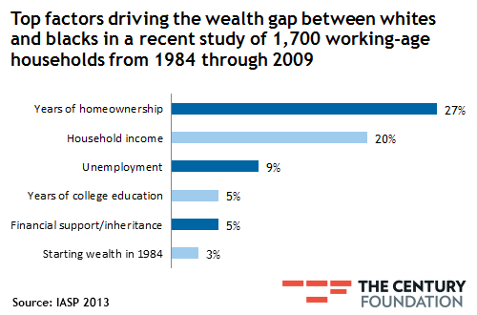
The second most important factor driving the racial wealth gap was household income. Although the median income gap between whites and blacks narrowed slightly between 1984 and 2009, the income gains of black households in the IASP study had a much smaller impact on their wealth accumulation. While every dollar increase in yearly income over the 25-year study period added $5.19 of wealth on average for a white household, it resulted in adding only 69 cents of wealth for blacks.
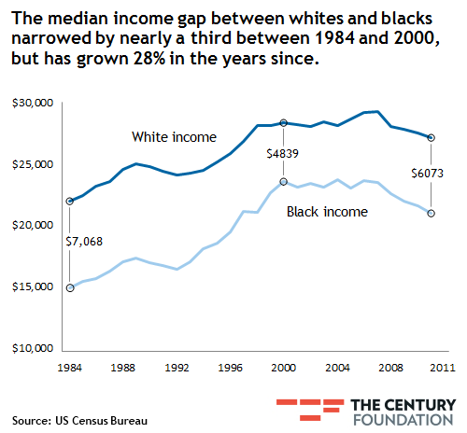
Part of this difference in wealth accumulation had its roots in "long-standing patterns of discrimination," particularly in the labor market, where black workers predominate in fields with lower pay and fewer benefits. "As a result, wealth in black families tends to be close to what is needed to cover emergency savings while wealth in white families is well beyond the emergency threshold and can be saved or invested more readily." In contrast, when white and black families started off with a similar amount of assets, the difference between their returns on wealth accumulation for each additional dollar earned narrowed significantly, with blacks increasing their yield to $4.03 of wealth per dollar earned.
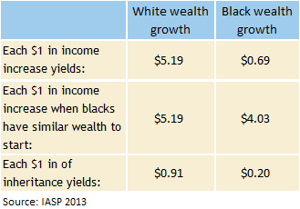
Many components of this wealth gap have their basis in historical problems of racial discrimination, as the report's authors note. But in a larger sense, their findings are just one dimension of the broader wealth inequality that divides all kinds of communities across the United States. The reason that the richest 1 percent of households own 37 percent of all national wealth mirrors the inequality of wealth accumulation between blacks and whites highlighted in the report.
Wealth compounds, by its very nature, giving high-net-worth families distinct advantages: Easy access to credit and family money, increasing the ability to take on risk; higher property values that fund better schools and safer communities; connections to higher education and better jobs. Until our public policy is able to address these fundamental inequalities of opportunity, the wealth gap will continue to grow, and compound.

