Colorado Funders for Inclusiveness & Equity
January 12, 2015
Meeting Notes

Welcome & Check-ins
New COFIE members were welcomed during the regular group “check-in”.

Updates
MOU—Adrienne, Erin, Nora and Jamie met to draft the MOU with The Chinook Fund. The MOU is awaiting final edits and will be signed shortly.

COFIE Leadership—Adrienne, Erin, Nora and Jamie will serve as the COFIE leadership team for 2015.

Round Robin Structure—Jamie provided an overview of the Round Robin structure suggested by Adrienne (based on one used by many groups, including the Denver Funders Forum) in which COFIE members could pose a question to the group for advice.

Members will be given an opportunity to vote/share their input on the proposed format in the 2015 Planning Survey. Watch your email!

Challenges & Wins in 2014 (bringing inclusiveness and equity more fully into your foundations)
Jamie led the group through an icebreaker activity. In pairs, respond to the following questions:
- What keeps us from speaking up/acting out against racism and other forms of oppression within our foundations?
- What propels us into action against racism and other forms of oppression within our foundations?

Jamie then reviewed the Courageous Conversations Compass, which helps people to better understand how they tend to engage in racialized conversations.

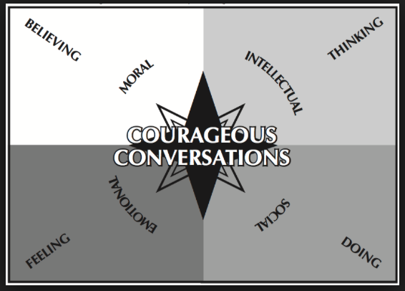

Group members were then asked to map their response to the following using the Compass:
- Affirmative Action
- Riots in Ferguson
- Charlie Hebdo Attack

Several people commented on how differently they did or would engage in a particular conversation based on the event’s proximity. For example, issues like Affirmative Action, which was part of social dialogue in the past, were more likely to be approached from an Intellectual/Thinking position, versus more recent and/or geographically near events like Ferguson. The activity elicited a lot of interesting conversation, with participants sharing diverse points of view.

Case Study
Participants were split into groups to discuss the case study example. They were asked to use the Courageous Conversations Compass to develop strategies for addressing the incident from diverse perspectives.

Next Steps:

- Jamie and Erin will send out meeting notes.
- Leadership team will follow up with MOU and other transition documents.
- Watch your email for annual survey from Jamie.

